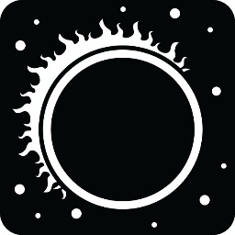
Tips for Watching the Great American Eclipse
August 21, 2017

How the eclipse is impacting Georgia:
- Extreme Northeast corner will see the complete eclipse beginning at around 2:34pm
- Best place to watch the eclipse: Rabun County where they will see a 2 minute and 34 second total eclipse beginning at 2:35pm.
- Beware of traffic! Anticipate lots of people for areas directly in the path of the total eclipse. Lots of people equals lots of traffic.

What will be visible in Greater Atlanta area:
- We will see a 97% partial eclipse at 2:36pm
- Check out lots of organized eclipse events https://eclipse2017.nasa.gov/event-locations

How to watch the eclipse safely:
- NASA recommends that solar viewing or eclipse glasses meet the current standard of ISO 12312-2
- Homemade filters or ordinary sunglasses are not safe for looking at the sun.
- If you look through binoculars, telescope or camera, you’ll need to get solar filters for them in order to view the sun safely.
- Stand still and cover your eyes with your eclipse glasses or solar viewer before looking up at the bright sun. After glancing at the sun, turn away and remove your filter — do not remove it while looking at the sun.

The next eclipse that impacts the United States will be in 2024 for Texas and up through the Midwest and northeastern part of our country.

Check out these other websites for more information!

Live video streams: https://www.nasa.gov/eclipselive

https://www.space.com/33797-total-solar-eclipse-2017-guide.html

Interactive Map: https://eclipse2017.nasa.gov/sites/default/files/interactive_map/index.html#

